

Physiotherapy Board of Australia

Registrant data

Reporting period: 1 July 2018 – 30 September 2018

Table of contents
Introduction 3
Principal Place of Practice 4
1. Registration Type 4
2. Endorsements by Type 4
Age Group 5
3. Registration Type and Subtype 5
Gender 6
4. Registration Type 6
5. Percentage 6

Introduction
The role of the Physiotherapy Board of Australia (the Board) includes:
- registering physiotherapists and students
- developing standards, codes and guidelines for the physiotherapy profession
- handling notifications, complaints, investigations and disciplinary hearings
- overseeing the assessment of overseas trained physiotherapists who wish to practise in Australia, and
- approving accreditation standards and accredited courses of study.
The Board’s functions are supported by the Australian Health Practitioner Regulation Agency (AHPRA). For information about legislation governing our operations see About AHPRA at www.ahpra.gov.au/About-AHPRA/What-We-Do/Legislation.aspx.
The Board has analysed its registration data and produced a number of statistical breakdowns about registrants to share with the profession and community. The Board shares these breakdowns regularly.
For more information on physiotherapy registration, please see the Board’s website www.physiotherapyboard.gov.au/Registration.aspx

Principal place of practice
- Registration type
  - Registration type and subtype by principal place of practice
Registration type | Registration subtype | ACT | NSW | NT | QLD | SA | TAS | VIC | WA | No PPP | Total
General |  | 646 | 8,940 | 176 | 5,867 | 2,414 | 479 | 7,444 | 3,593 | 1,041 | 30,600
Limited | Postgraduate training or supervised practice | 2 | 101 | 4 | 62 | 43 | 5 | 217 | 47 | 2 | 483
Limited | Teaching or research |  | 8 |  | 3 |  |  | 2 |  |  | 13
Non-practising |  | 14 | 316 | 2 | 176 | 44 | 7 | 246 | 120 | 197 | 1,122
Total |  | 662 | 9,365 | 182 | 6,108 | 2,501 | 491 | 7,909 | 3,760 | 1,240 | 32,218

  - Registration type by principal place of practice percentages
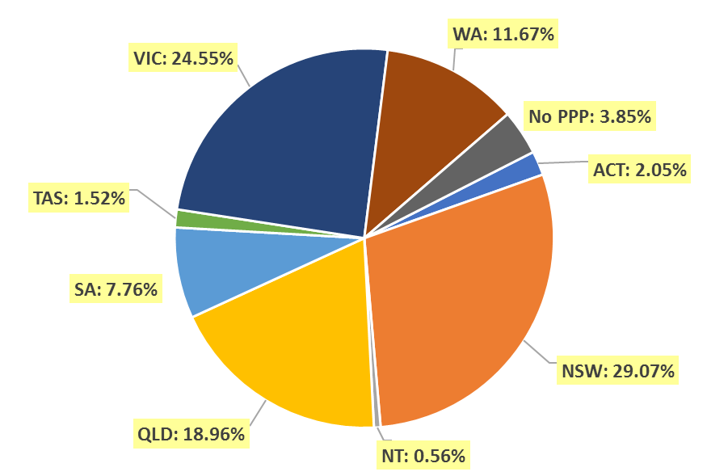

Endorsements by type

  - Endorsements
Endorsement | ACT | NSW | NT | QLD | SA | TAS | VIC | WA | No PPP | Total
Acupuncture |  |  |  |  |  |  | 6 |  |  | 6

Age group
- Registration type and subtype
  - Registration by age group
Age group | General | Limited |  | Non-practising | Total
Age group | General | Postgraduate training or supervised practice | Teaching or research | Non-practising | Total
U - 25 | 2,250 | 9 |  | 6 | 2,265
25 - 29 | 6,635 | 184 |  | 103 | 6,922
30 - 34 | 5,609 | 193 | 2 | 190 | 5,994
35 - 39 | 4,209 | 60 | 2 | 149 | 4,420
40 - 44 | 3,041 | 29 | 3 | 148 | 3,221
45 - 49 | 2,623 | 6 | 2 | 122 | 2,753
50 - 54 | 2,106 | 1 | 4 | 96 | 2,207
55 - 59 | 1,891 | 1 |  | 94 | 1,986
60 - 64 | 1,448 |  |  | 93 | 1,541
65 - 69 | 525 |  |  | 59 | 584
70 - 74 | 192 |  |  | 37 | 229
75 - 79 | 55 |  |  | 15 | 70
80+ | 16 |  |  | 10 | 26
Total | 30,600 | 483 | 13 | 1,122 | 32,218

  - Registration by age group

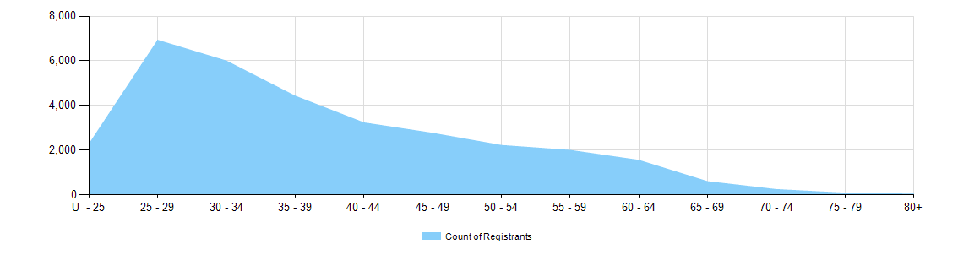

Gender
- Registration type
  - Gender by state and territory by registration type
Gender | Registration type | Subtype | ACT | NSW | NT | QLD | SA | TAS | VIC | WA | No PPP | Total
Female | General |  | 439 | 5,805 | 122 | 3,814 | 1,545 | 334 | 4,996 | 2,549 | 698 | 20,302
Female | Limited | Postgrad training or supervised practice | 1 | 68 | 2 | 44 | 31 | 5 | 155 | 28 | 1 | 335
Female | Limited | Teaching or research |  | 4 |  | 3 |  |  | 1 |  |  | 8
Female | Non-practising |  | 10 | 256 | 1 | 138 | 37 | 4 | 201 | 90 | 146 | 883
Total female |  |  | 450 | 6,133 | 125 | 3,999 | 1,613 | 343 | 5,353 | 2,667 | 845 | 21,528
Male | General |  | 207 | 3,135 | 54 | 2,053 | 869 | 145 | 2,448 | 1,044 | 343 | 10,298
Male | Limited | Postgrad training or supervised practice | 1 | 33 | 2 | 18 | 12 |  | 62 | 19 | 1 | 148
Male | Limited | Teaching or research |  | 4 |  |  |  |  | 1 |  |  | 5
Male | Non-practising |  | 4 | 60 | 1 | 38 | 7 | 3 | 45 | 30 | 51 | 239
Total male |  |  | 212 | 3,232 | 57 | 2,109 | 888 | 148 | 2,556 | 1,093 | 395 | 10,690
Total |  |  | 662 | 9,365 | 182 | 6,108 | 2,501 | 491 | 7,909 | 3,760 | 1,240 | 32,218

- Percentage
  - Registrants by gender percentages
Gender | ACT | NSW | NT | QLD | SA | TAS | VIC | WA | No PPP | Total
Female | 68.0% | 65.5% | 68.7% | 65.5% | 64.5% | 69.9% | 67.7% | 70.9% | 68.1% | 66.8%
Male | 32.0% | 34.5% | 31.3% | 34.5% | 35.5% | 30.1% | 32.3% | 29.1% | 31.9% | 33.2%

