

Physiotherapy Board of Australia

Registrant Data

Reporting period: 1 April 2016 – 30 June 2016

Table of contents
Introduction 3
Principal Place of Practice 4
1. Registration Type 4
2. Endorsements by Type 4
Age Group 5
3. Registration Type and Sub type 5
Gender 6
4. Registration Type 6
5. Percentage 6

Introduction
The role of the Physiotherapy Board of Australia (the Board) includes:
- registering physiotherapists and students
- developing standards, codes and guidelines for the physiotherapy profession
- handling notifications, complaints, investigations and disciplinary hearings
- overseeing the assessment of overseas trained physiotherapists who wish to practise in Australia, and
- approving accreditation standards and accredited courses of study.
The Board’s functions are supported by the Australian Health Practitioner Regulation Agency (AHPRA). For information about legislation governing our operations see About AHPRA at http://www.ahpra.gov.au/About-AHPRA/What-We-Do/Legislation.aspx.
The Board has analysed its registration data and produced a number of statistical breakdowns about registrants to share with the profession and community. The Board shares these breakdowns regularly.
For more information on physiotherapy registration, please see the Board’s website http://www.physiotherapyboard.gov.au/Registration.aspx

Principal Place of Practice
- Registration Type
  - Registration type and sub type by principal place of practice
Registration Type | Registration Sub-type | ACT | NSW | NT | QLD | SA | TAS | VIC | WA | No PPP | Total
General |  | 528 | 8,099 | 162 | 5,188 | 2,229 | 430 | 6,706 | 3,369 | 956 | 27,667
Limited | Postgraduate training or supervised practice | 2 | 54 | 2 | 41 | 23 | 14 | 154 | 38 | 2 | 330
Limited | Teaching or research |  | 10 |  | 4 |  |  | 2 |  |  | 16
Non-practising |  | 9 | 245 | 1 | 116 | 37 | 6 | 198 | 68 | 162 | 842
Total |  | 539 | 8,408 | 165 | 5,349 | 2,289 | 450 | 7,060 | 3,475 | 1,120 | 28,855

  - Registration type by principal place of practice percentages

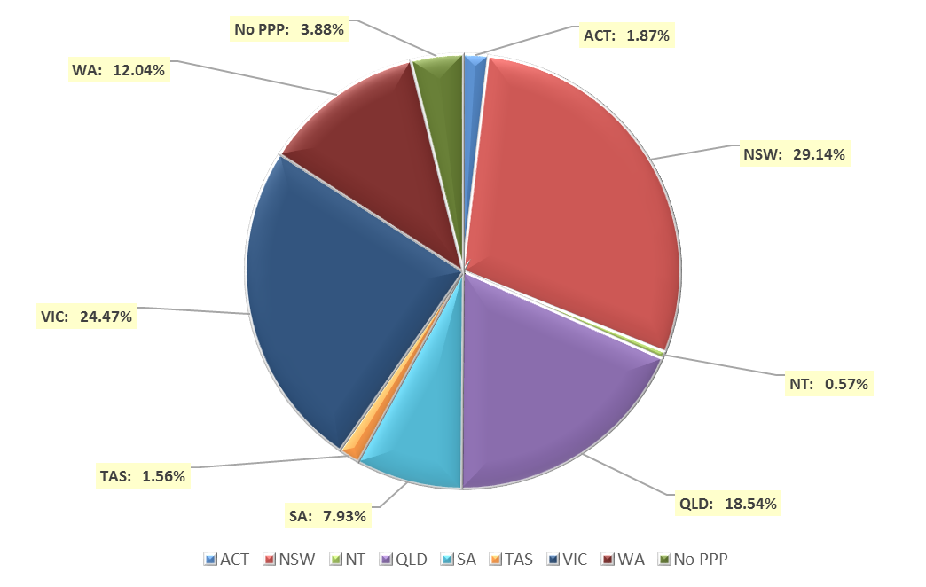

- Endorsements by Type
  - Endorsements
Endorsement | ACT | NSW | NT | QLD | SA | TAS | VIC | WA | No PPP | Total
Acupuncture |  |  |  |  |  |  | 8 |  |  | 8

Age Group
- Registration Type and Sub type
  - Registration by age group
Age Group | General | Limited |  | Non-practising | Total
Age Group | General | Postgraduate training or supervised practice | Teaching or research | Non-practising | Total
U - 25 | 2,369 | 9 |  | 7 | 2,385
25 - 29 | 5,954 | 120 | 1 | 112 | 6,187
30 - 34 | 4,751 | 134 | 4 | 111 | 5,000
35 - 39 | 3,639 | 43 | 2 | 120 | 3,804
40 - 44 | 2,796 | 14 | 3 | 126 | 2,939
45 - 49 | 2,410 | 8 | 5 | 82 | 2,505
50 - 54 | 2,030 | 2 | 1 | 70 | 2,103
55 - 59 | 1,937 |  |  | 80 | 2,017
60 - 64 | 1,095 |  |  | 51 | 1,146
65 - 69 | 473 |  |  | 37 | 510
70 - 74 | 153 |  |  | 25 | 178
75 - 79 | 48 |  |  | 14 | 62
80+ | 12 |  |  | 7 | 19
Total | 27,667 | 330 | 16 | 842 | 28,855

  - Registration by age group

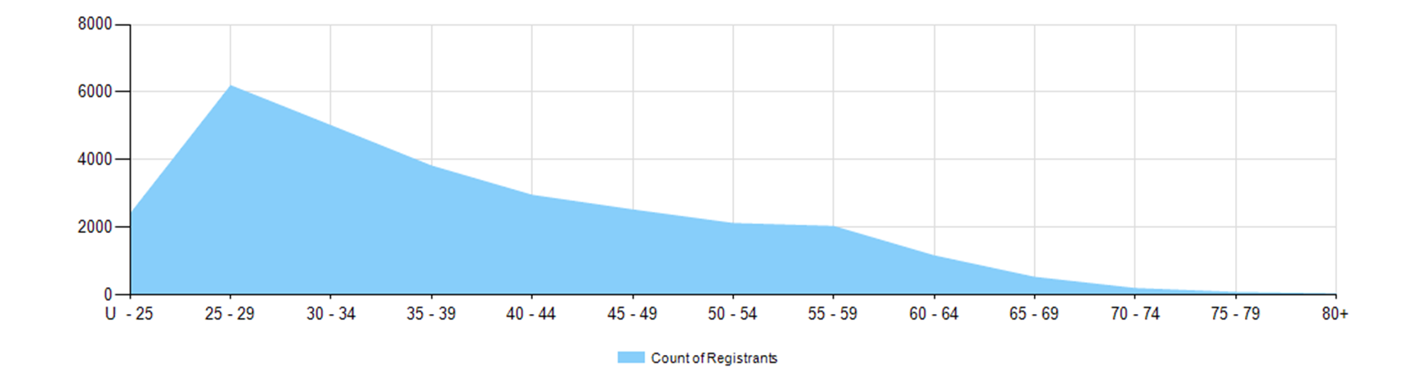

Gender
- Registration Type
  - Gender by state and territory by registration type
Gender | Registration Type | Sub Type | ACT | NSW | NT | QLD | SA | TAS | VIC | WA | No PPP | Total
Female | General |  | 358 | 5,431 | 113 | 3,473 | 1,442 | 313 | 4,557 | 2,404 | 657 | 18,748
Female | Limited | Postgrad training or supervised practice | 2 | 43 | 2 | 24 | 13 | 8 | 110 | 23 | 2 | 227
Female | Limited | Teaching or research |  | 6 |  | 3 |  |  | 1 |  |  | 10
Female | Non-practising |  | 8 | 204 | 1 | 80 | 31 | 5 | 157 | 50 | 118 | 654
Total Female |  |  | 368 | 5,684 | 116 | 3,580 | 1,486 | 326 | 4,825 | 2,477 | 777 | 19,639
Male | General |  | 170 | 2,668 | 49 | 1,715 | 787 | 117 | 2,149 | 965 | 299 | 8,919
Male | Limited | Postgrad training or supervised practice |  | 11 |  | 17 | 10 | 6 | 44 | 15 |  | 103
Male | Limited | Teaching or research |  | 4 |  | 1 |  |  | 1 |  |  | 6
Male | Non-practising |  | 1 | 41 |  | 36 | 6 | 1 | 41 | 18 | 44 | 188
Total Male |  |  | 171 | 2,724 | 49 | 1,769 | 803 | 124 | 2,235 | 998 | 343 | 9,216
Total |  |  | 539 | 8,408 | 165 | 5,349 | 2,289 | 450 | 7,060 | 3,475 | 1,120 | 28,855

- Percentage
  - Registrants by gender percentages
Gender | ACT | NSW | NT | QLD | SA | TAS | VIC | WA | No PPP | Total
Female | 68.3% | 67.6% | 70.3% | 66.9% | 64.9% | 72.4% | 68.3% | 71.3% | 69.4% | 68.1%
Male | 31.7% | 32.4% | 29.7% | 33.1% | 35.1% | 27.6% | 31.7% | 28.7% | 30.6% | 31.9%

