

Physiotherapy Board of Australia

Registrant Data

Reporting period: 1 April 2017 – 30 June 2017

Table of contents
Introduction 3
Principal Place of Practice 4
1. Registration Type 4
2. Endorsements by Type 4
Age Group 5
3. Registration Type and Sub type 5
Gender 6
4. Registration Type 6
5. Percentage 6

Introduction
The role of the Physiotherapy Board of Australia (the Board) includes:
- registering physiotherapists and students
- developing standards, codes and guidelines for the physiotherapy profession
- handling notifications, complaints, investigations and disciplinary hearings
- overseeing the assessment of overseas trained physiotherapists who wish to practise in Australia, and
- approving accreditation standards and accredited courses of study.
The Board’s functions are supported by the Australian Health Practitioner Regulation Agency (AHPRA). For information about legislation governing our operations see About AHPRA at www.ahpra.gov.au/About-AHPRA/What-We-Do/Legislation.aspx.
The Board has analysed its registration data and produced a number of statistical breakdowns about registrants to share with the profession and community. The Board shares these breakdowns regularly.
For more information on physiotherapy registration, please see the Board’s website www.physiotherapyboard.gov.au/Registration.aspx

Principal Place of Practice
- Registration Type
  - Registration type and sub type by principal place of practice
Registration Type | Registration Sub-type | ACT | NSW | NT | QLD | SA | TAS | VIC | WA | No PPP | Total
General |  | 581 | 8,572 | 166 | 5,518 | 2,308 | 457 | 7,035 | 3,481 | 996 | 29,114
Limited | Postgraduate training or supervised practice | 1 | 64 | 3 | 50 | 31 | 11 | 159 | 35 | 1 | 355
Limited | Teaching or research |  | 10 |  | 4 |  |  | 2 |  |  | 16
Non-practising |  | 9 | 254 | 1 | 124 | 38 | 6 | 187 | 82 | 165 | 866
Total |  | 591 | 8,900 | 170 | 5,696 | 2,377 | 474 | 7,383 | 3,598 | 1,162 | 30,351

  - Registration type by principal place of practice percentages
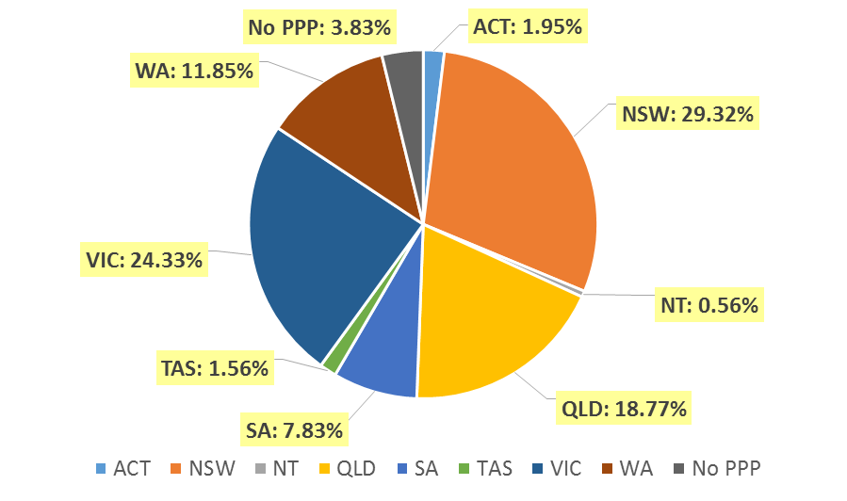

Endorsements by Type
  - Endorsements
Endorsement | ACT | NSW | NT | QLD | SA | TAS | VIC | WA | No PPP | Total
Acupuncture |  |  |  |  |  |  | 7 |  |  | 7

Age Group
- Registration Type and Sub type
  - Registration by age group
Age Group | General | Limited |  | Non-practising | Total
Age Group | General | Postgraduate training or supervised practice | Teaching or research | Non-practising | Total
U - 25 | 2,496 | 6 |  | 9 | 2,511
25 - 29 | 6,211 | 131 |  | 106 | 6,448
30 - 34 | 5,149 | 146 | 4 | 124 | 5,423
35 - 39 | 3,905 | 50 | 1 | 114 | 4,070
40 - 44 | 2,879 | 16 | 4 | 124 | 3,023
45 - 49 | 2,516 | 6 | 5 | 90 | 2,617
50 - 54 | 2,079 |  | 2 | 75 | 2,156
55 - 59 | 1,928 |  |  | 83 | 2,011
60 - 64 | 1,249 |  |  | 55 | 1,304
65 - 69 | 472 |  |  | 43 | 515
70 - 74 | 170 |  |  | 22 | 192
75 - 79 | 47 |  |  | 16 | 63
80+ | 13 |  |  | 5 | 18
Total | 29,114 | 355 | 16 | 866 | 30,351

  - Registration by age group

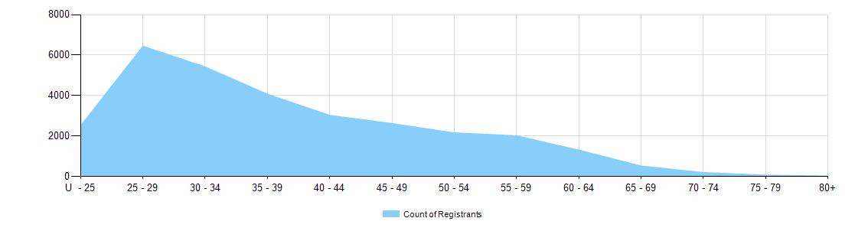

Gender
- Registration Type
  - Gender by state and territory by registration type
Gender | Registration Type | Sub Type | ACT | NSW | NT | QLD | SA | TAS | VIC | WA | No PPP | Total
Female | General |  | 392 | 5,665 | 120 | 3,659 | 1,490 | 324 | 4,747 | 2,477 | 689 | 19,563
Female | Limited | Postgrad training or supervised practice |  | 51 | 2 | 31 | 23 | 7 | 106 | 22 |  | 242
Female | Limited | Teaching or research |  | 5 |  | 4 |  |  | 1 |  |  | 10
Female | Non-practising |  | 7 | 207 | 1 | 92 | 33 | 5 | 149 | 60 | 120 | 674
Total Female |  |  | 399 | 5,928 | 123 | 3,786 | 1,546 | 336 | 5,003 | 2,559 | 809 | 20,489
Male | General |  | 189 | 2,907 | 46 | 1,859 | 818 | 133 | 2,288 | 1,004 | 307 | 9,551
Male | Limited | Postgrad training or supervised practice | 1 | 13 | 1 | 19 | 8 | 4 | 53 | 13 | 1 | 113
Male | Limited | Teaching or research |  | 5 |  |  |  |  | 1 |  |  | 6
Male | Non-practising |  | 2 | 47 |  | 32 | 5 | 1 | 38 | 22 | 45 | 192
Total Male |  |  | 192 | 2,972 | 47 | 1,910 | 831 | 138 | 2,380 | 1,039 | 353 | 9,862
Total |  |  | 591 | 8,900 | 170 | 5,696 | 2,377 | 474 | 7,383 | 3,598 | 1,162 | 30,351

- Percentage
  - Registrants by gender percentages
Gender | ACT | NSW | NT | QLD | SA | TAS | VIC | WA | No PPP | Total
Female | 67.5% | 66.6% | 72.4% | 66.5% | 65.0% | 70.9% | 67.8% | 71.1% | 69.6% | 67.5%
Male | 32.5% | 33.4% | 27.6% | 33.5% | 35.0% | 29.1% | 32.2% | 28.9% | 30.4% | 32.5%

