

Physiotherapy Board of Australia

Registrant Data

Reporting period: 1 July 2016 – 30 September 2016

Table of contents
Introduction 3
Principal Place of Practice 4
1. Registration Type 4
2. Endorsements by Type 4
Age Group 5
3. Registration Type and Sub type 5
Gender 6
4. Registration Type 6
5. Percentage 6

Introduction
The role of the Physiotherapy Board of Australia (the Board) includes:
- registering physiotherapists and students
- developing standards, codes and guidelines for the physiotherapy profession
- handling notifications, complaints, investigations and disciplinary hearings
- overseeing the assessment of overseas trained physiotherapists who wish to practise in Australia, and
- approving accreditation standards and accredited courses of study.
The Board’s functions are supported by the Australian Health Practitioner Regulation Agency (AHPRA). For information about legislation governing our operations see About AHPRA at http://www.ahpra.gov.au/About-AHPRA/What-We-Do/Legislation.aspx.
The Board has analysed its registration data and produced a number of statistical breakdowns about registrants to share with the profession and community. The Board shares these breakdowns regularly.
For more information on physiotherapy registration, please see the Board’s website http://www.physiotherapyboard.gov.au/Registration.aspx

Principal Place of Practice
- Registration Type
  - Registration type and sub type by principal place of practice
Registration Type | Registration Sub-type | ACT | NSW | NT | QLD | SA | TAS | VIC | WA | No PPP | Total
General |  | 545 | 8,186 | 161 | 5,212 | 2,248 | 432 | 6,731 | 3,379 | 971 | 27,865
Limited | Postgraduate training or supervised practice | 1 | 65 | 3 | 44 | 24 | 12 | 156 | 38 | 3 | 346
Limited | Teaching or research |  | 11 |  | 4 |  |  | 1 |  |  | 16
Non-practising |  | 8 | 245 | 1 | 120 | 37 | 6 | 195 | 68 | 161 | 841
Total |  | 554 | 8,507 | 165 | 5,380 | 2,309 | 450 | 7,083 | 3,485 | 1,135 | 29,068

  - Registration type by principal place of practice percentages

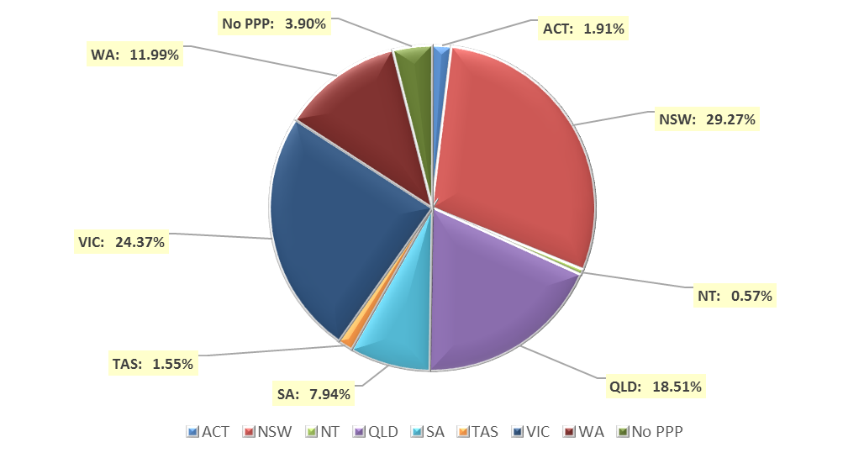

- Endorsements by Type
  - Endorsements
Endorsement | ACT | NSW | NT | QLD | SA | TAS | VIC | WA | No PPP | Total
Acupuncture |  |  |  |  |  |  | 8 |  |  | 8

Age Group
- Registration Type and Sub type
  - Registration by age group
Age Group | General | Limited |  | Non-practising | Total
Age Group | General | Postgraduate training or supervised practice | Teaching or research | Non-practising | Total
U - 25 | 2,146 | 8 |  | 6 | 2,160
25 - 29 | 6,050 | 132 | 1 | 104 | 6,287
30 - 34 | 4,823 | 131 | 3 | 113 | 5,070
35 - 39 | 3,713 | 50 | 1 | 121 | 3,885
40 - 44 | 2,841 | 15 | 4 | 121 | 2,981
45 - 49 | 2,445 | 8 | 6 | 86 | 2,545
50 - 54 | 2,049 | 2 | 1 | 73 | 2,125
55 - 59 | 1,933 |  |  | 79 | 2,012
60 - 64 | 1,154 |  |  | 52 | 1,206
65 - 69 | 486 |  |  | 36 | 522
70 - 74 | 163 |  |  | 28 | 191
75 - 79 | 49 |  |  | 15 | 64
80+ | 13 |  |  | 7 | 20
Total | 27,865 | 346 | 16 | 841 | 29,068

  - Registration by age group

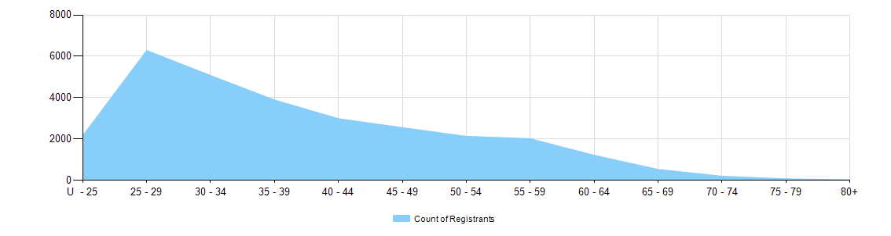

Gender
- Registration Type
  - Gender by state and territory by registration type
Gender | Registration Type | Sub Type | ACT | NSW | NT | QLD | SA | TAS | VIC | WA | No PPP | Total
Female | General |  | 369 | 5,475 | 113 | 3,493 | 1,448 | 312 | 4,570 | 2,413 | 666 | 18,859
Female | Limited | Postgrad training or supervised practice | 1 | 53 | 3 | 24 | 15 | 7 | 109 | 23 | 2 | 237
Female | Limited | Teaching or research |  | 7 |  | 3 |  |  |  |  |  | 10
Female | Non-practising |  | 7 | 203 | 1 | 83 | 32 | 5 | 156 | 50 | 117 | 654
Total Female |  |  | 377 | 5,738 | 117 | 3,603 | 1,495 | 324 | 4,835 | 2,486 | 785 | 19,760
Male | General |  | 176 | 2,711 | 48 | 1,719 | 800 | 120 | 2,161 | 966 | 305 | 9,006
Male | Limited | Postgrad training or supervised practice |  | 12 |  | 20 | 9 | 5 | 47 | 15 | 1 | 109
Male | Limited | Teaching or research |  | 4 |  | 1 |  |  | 1 |  |  | 6
Male | Non-practising |  | 1 | 42 |  | 37 | 5 | 1 | 39 | 18 | 44 | 187
Total Male |  |  | 177 | 2,769 | 48 | 1,777 | 814 | 126 | 2,248 | 999 | 350 | 9,308
Total |  |  | 554 | 8,507 | 165 | 5,380 | 2,309 | 450 | 7,083 | 3,485 | 1,135 | 29,068

- Percentage
  - Registrants by gender percentages
Gender | ACT | NSW | NT | QLD | SA | TAS | VIC | WA | No PPP | Total
Female | 68.1% | 67.5% | 70.9% | 67% | 64.7% | 72% | 68.3% | 71.3% | 69.2% | 68%
Male | 31.9% | 32.5% | 29.1% | 33% | 35.3% | 28% | 31.7% | 28.7% | 30.8% | 32%

