

Physiotherapy Board of Australia

Registrant Data

Reporting period: 1 July 2017 – 30 September 2017

Table of contents
Introduction 3
Principal Place of Practice 4
1. Registration Type 4
2. Endorsements by Type 4
Age Group 5
3. Registration Type and Sub type 5
Gender 6
4. Registration Type 6
5. Percentage 6

Introduction
The role of the Physiotherapy Board of Australia (the Board) includes:
- registering physiotherapists and students
- developing standards, codes and guidelines for the physiotherapy profession
- handling notifications, complaints, investigations and disciplinary hearings
- overseeing the assessment of overseas trained physiotherapists who wish to practise in Australia, and
- approving accreditation standards and accredited courses of study.
The Board’s functions are supported by the Australian Health Practitioner Regulation Agency (AHPRA). For information about legislation governing our operations see About AHPRA at www.ahpra.gov.au/About-AHPRA/What-We-Do/Legislation.aspx.
The Board has analysed its registration data and produced a number of statistical breakdowns about registrants to share with the profession and community. The Board shares these breakdowns regularly.
For more information on physiotherapy registration, please see the Board’s website www.physiotherapyboard.gov.au/Registration.aspx

Principal Place of Practice
- Registration Type
  - Registration type and sub type by principal place of practice
Registration Type | Registration Sub-type | ACT | NSW | NT | QLD | SA | TAS | VIC | WA | No PPP | Total
General |  | 603 | 8,650 | 165 | 5,548 | 2,323 | 461 | 7,068 | 3,494 | 1,008 | 29,320
Limited | Postgraduate training or supervised practice | 1 | 69 | 3 | 54 | 29 | 10 | 176 | 34 |  | 376
Limited | Teaching or research |  | 10 |  | 4 |  |  | 2 |  |  | 16
Non-practising |  | 9 | 251 | 1 | 122 | 37 | 6 | 186 | 83 | 167 | 862
Total |  | 613 | 8,980 | 169 | 5,728 | 2,389 | 477 | 7,432 | 3,611 | 1,175 | 30,574

  - Registration type by principal place of practice percentages
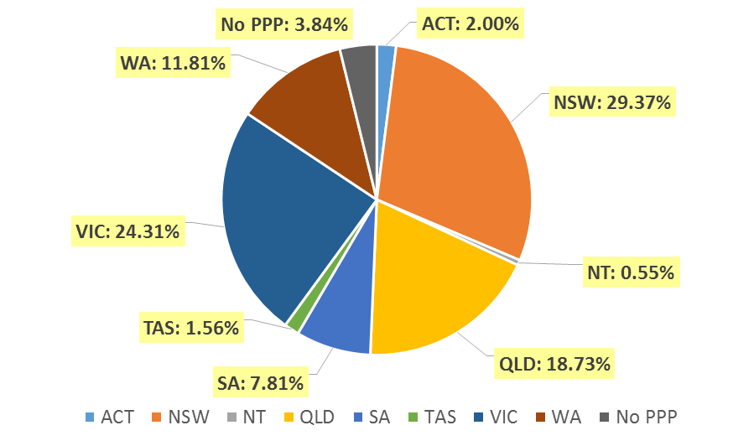

Endorsements by Type

  - Endorsements
Endorsement | ACT | NSW | NT | QLD | SA | TAS | VIC | WA | No PPP | Total
Acupuncture |  |  |  |  |  |  | 7 |  |  | 7

Age Group
- Registration Type and Sub type
  - Registration by age group
Age Group | General | Limited |  | Non-practising | Total
Age Group | General | Postgraduate training or supervised practice | Teaching or research | Non-practising | Total
U - 25 | 2,241 | 6 |  | 8 | 2,255
25 - 29 | 6,267 | 145 |  | 101 | 6,513
30 - 34 | 5,282 | 152 | 4 | 122 | 5,560
35 - 39 | 3,993 | 51 | 1 | 117 | 4,162
40 - 44 | 2,922 | 16 | 4 | 119 | 3,061
45 - 49 | 2,512 | 6 | 4 | 90 | 2,612
50 - 54 | 2,122 |  | 3 | 79 | 2,204
55 - 59 | 1,929 |  |  | 78 | 2,007
60 - 64 | 1,311 |  |  | 58 | 1,369
65 - 69 | 493 |  |  | 46 | 539
70 - 74 | 184 |  |  | 23 | 207
75 - 79 | 50 |  |  | 16 | 66
80+ | 14 |  |  | 5 | 19
Total | 29,320 | 376 | 16 | 862 | 30,574

  - Registration by age group

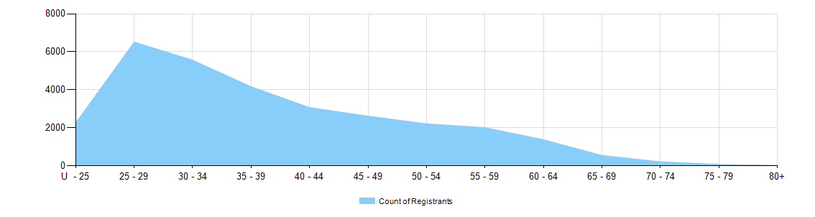

Gender
- Registration Type
  - Gender by state and territory by registration type
Gender | Registration Type | Sub Type | ACT | NSW | NT | QLD | SA | TAS | VIC | WA | No PPP | Total
Female | General |  | 406 | 5,696 | 118 | 3,675 | 1,502 | 327 | 4,764 | 2,488 | 693 | 19,669
Female | Limited | Postgrad training or supervised practice |  | 54 | 2 | 35 | 23 | 7 | 121 | 19 |  | 261
Female | Limited | Teaching or research |  | 5 |  | 4 |  |  | 1 |  |  | 10
Female | Non-practising |  | 7 | 205 | 1 | 90 | 32 | 5 | 150 | 61 | 121 | 672
Total Female |  |  | 413 | 5,960 | 121 | 3,804 | 1,557 | 339 | 5,036 | 2,568 | 814 | 20,612
Male | General |  | 197 | 2,954 | 47 | 1,873 | 821 | 134 | 2,304 | 1,006 | 315 | 9,651
Male | Limited | Postgrad training or supervised practice | 1 | 15 | 1 | 19 | 6 | 3 | 55 | 15 |  | 115
Male | Limited | Teaching or research |  | 5 |  |  |  |  | 1 |  |  | 6
Male | Non-practising |  | 2 | 46 |  | 32 | 5 | 1 | 36 | 22 | 46 | 190
Total Male |  |  | 200 | 3,020 | 48 | 1,924 | 832 | 138 | 2,396 | 1,043 | 361 | 9,962
Total |  |  | 613 | 8,980 | 169 | 5,728 | 2,389 | 477 | 7,432 | 3,611 | 1,175 | 30,574

- Percentage
  - Registrants by gender percentages
Gender | ACT | NSW | NT | QLD | SA | TAS | VIC | WA | No PPP | Total
Female | 67.4% | 66.4% | 71.6% | 66.4% | 65.2% | 71.1% | 67.8% | 71.1% | 69.3% | 67.4%
Male | 32.6% | 33.6% | 28.4% | 33.6% | 34.8% | 28.9% | 32.2% | 28.9% | 30.7% | 32.6%

