Physiotherapy Registrant Data: December 2012

Published January 2013

Introduction
The functions of the Physiotherapy Board of Australia include:
- registering physiotherapists and students
- developing standards, codes and guidelines for the physiotherapy profession
- handling notifications, complaints, investigations and disciplinary hearings
- assessing overseas trained practitioners who wish to practise in Australia
- approving accreditation standards and accredited courses of study.

The Board’s functions are supported by Australian Health Practitioner Regulation Agency (AHPRA). For information about legislation governing our operations see AHPRA's Legislation & Publications at http://www.ahpra.gov.au/Legislation-and-Publications.aspx

The Board has analysed its registration data and produced a number of statistical breakdowns about registrants to share with the profession and community. The Board shares these breakdowns regularly.

For more information on physiotherapy registration, please see the Board’s website:
www.physiotherapyboard.gov.au/Registration.aspx

Index of Tables
Physiotherapists: State andterritory by registration type 2
Physiotherapists: Age by registration type 3
Physiotherapists: Gender by state andterritory by registration type 4
Physiotherapists: Endorsement type by state and territory 4

Please Note: The numbers in this report reflect the National Board’s registration data as at 31 December 2012. These statistics include approximately 538 registrants who did not renew their registration by the end of the registration renewal late period for this profession, and were removed from the register on 3 January 2013, as required by the National Law.

Physiotherapists: State and territory by registration type
State | General | Limited |  |  | Non-practising | Total | % By State
 |  | Postgraduate training or supervised practice | Public interest | Teaching or research
ACT | 449 |  | 2 |  | 11 | 462 | 1.9%
NSW | 6,688 | 19 | 12 | 5 | 211 | 6,935 | 28.53%
NT | 151 |  |  |  | 1 | 152 | 0.63%
QLD | 4,423 | 27 | 3 | 1 | 73 | 4,527 | 18.63%
SA | 1,878 | 36 | 8 |  | 15 | 1,937 | 7.97%
TAS | 392 | 3 |  |  | 6 | 401 | 1.65%
VIC | 5,722 | 59 | 22 | 4 | 196 | 6,003 | 24.7%
WA | 2,897 | 30 | 1 | 1 | 62 | 2,991 | 12.31%
Not Stated | 782 | 5 |  | 3 | 106 | 896 | 3.69%
Total | 23,382 | 179 | 48 | 14 | 681 | 24,304

% By state and territory

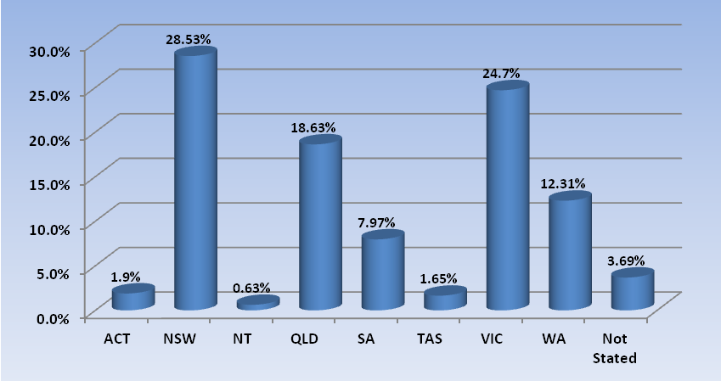

Physiotherapists: Age by registration type
Age Group | General | Limited |  |  | Non-practising | Total | % By Age Group
 |  | Postgraduate training or supervised practice | Public interest | Teaching or research
21 - 25 | 2,102 | 8 | 2 |  | 8 | 2,120 | 8.72%
26 - 30 | 4,765 | 86 | 20 | 1 | 68 | 4,940 | 20.33%
31 - 35 | 3,931 | 66 | 17 | 1 | 100 | 4,115 | 16.93%
36 - 40 | 2,904 | 10 | 4 | 4 | 117 | 3,039 | 12.49%
41 - 45 | 2,546 | 7 | 3 | 2 | 98 | 2,656 | 10.93%
46 - 50 | 2,145 | 2 | 2 | 3 | 71 | 2,223 | 9.14%
51 - 55 | 2,047 |  |  | 1 | 63 | 2,111 | 8.69%
56 - 60 | 1,598 |  |  | 1 | 42 | 1,641 | 6.75%
61 - 65 | 773 |  |  | 1 | 44 | 818 | 3.37%
66 - 70 | 375 |  |  |  | 44 | 419 | 1.72%
71 - 75 | 136 |  |  |  | 16 | 152 | 0.63%
76 - 80 | 39 |  |  |  | 8 | 47 | 0.19%
81 - 85 | 9 |  |  |  | 2 | 11 | 0.05%
86 + | 3 |  |  |  |  | 3 | 0.01%
Not Stated | 9 |  |  |  |  | 9 | 0.04%
Total | 23,382 | 179 | 48 | 14 | 681 | 24,304

% By age group
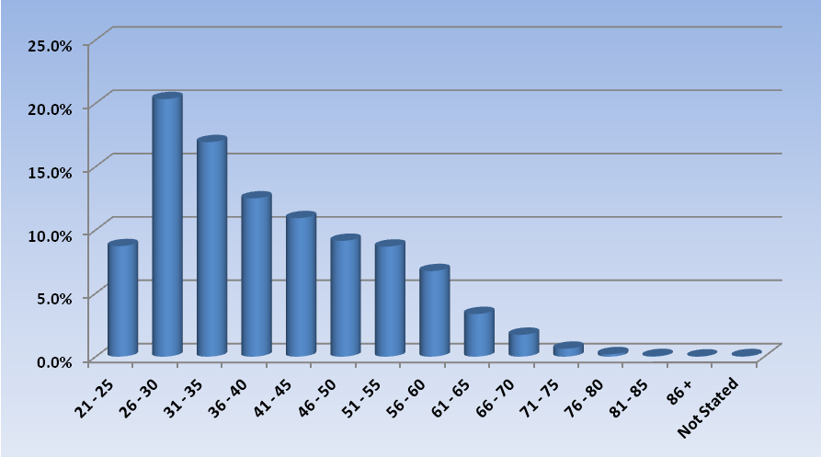

Physiotherapists: Gender by state and territory by registration type
Sex | State | General | Limited |  |  | Non-practising | Total Count | % By Sex By State
 |  |  | Postgraduate training or supervised practice | Public interest | Teaching or research
Female | ACT | 326 |  | 2 |  | 9 | 337 | 1.39%
Female | NSW | 4,696 | 16 | 9 | 3 | 183 | 4,907 | 20.19%
Female | NT | 102 |  |  |  | 1 | 103 | 0.42%
Female | QLD | 3,046 | 20 | 3 | 1 | 56 | 3,126 | 12.86%
Female | SA | 445 | 22 | 3 |  | 10 | 480 | 1.97%
Female | TAS | 302 | 1 |  |  | 5 | 308 | 1.27%
Female | VIC | 3,885 | 42 | 15 | 3 | 151 | 4,096 | 16.85%
Female | WA | 2,085 | 19 | 1 |  | 49 | 2,154 | 8.86%
Female | Not Stated | 521 | 3 |  | 2 | 70 | 596 | 2.45%
Female | Sub total | 15,408 | 123 | 33 | 9 | 534 | 16,107 | 66.27%
Male | ACT | 121 |  |  |  | 2 | 123 | 0.51%
Male | NSW | 1,976 | 3 | 3 | 2 | 28 | 2,012 | 8.28%
Male | NT | 47 |  |  |  |  | 47 | 0.19%
Male | QLD | 1,366 | 7 |  |  | 17 | 1,390 | 5.72%
Male | SA | 221 | 13 | 5 |  | 2 | 241 | 0.99%
Male | TAS | 88 | 2 |  |  | 1 | 91 | 0.37%
Male | VIC | 1,763 | 17 | 7 | 1 | 44 | 1,832 | 7.54%
Male | WA | 800 | 11 |  | 1 | 13 | 825 | 3.39%
Male | Not Stated | 206 | 2 |  | 1 | 34 | 243 | 1.0%
Male | Sub total | 6,588 | 55 | 15 | 5 | 141 | 6,804 | 28.0%
Not Stated | ACT | 2 |  |  |  |  | 2 | 0.01%
Not Stated | NSW | 16 |  |  |  |  | 16 | 0.07%
Not Stated | NT | 2 |  |  |  |  | 2 | 0.01%
Not Stated | QLD | 11 |  |  |  |  | 11 | 0.05%
Not Stated | SA | 1,212 | 1 |  |  | 3 | 1,216 | 5.0%
Not Stated | TAS | 2 |  |  |  |  | 2 | 0.01%
Not Stated | VIC | 74 |  |  |  | 1 | 75 | 0.31%
Not Stated | WA | 12 |  |  |  |  | 12 | 0.05%
Not Stated | Not Stated | 55 |  |  |  | 2 | 57 | 0.23%
Not Stated | Sub total | 1,386 | 1 |  |  | 6 | 1,393 | 5.73%
Total |  | 23,382 | 179 | 48 | 14 | 681 | 24,304

Physiotherapists: Endorsement type by state/territory
Endorsement | VIC | Total
Acupuncture | 9 | 9
Total | 9 | 9

